GULISTAN & TURGUT OZAL EDUCATIONAL INSTITUTIONS
INFORMATICS LESSON PLAN

DATE : DURATION: 40 minutes
GRADE LEVEL : 10th Class
SUBJECT : Standard functions - 3
OBJECTIVES : To learn how to use standard functions, Boolean Operations and Decision Statements
LESSON PLAN
Key words :
Warm-up :

Introduction and explanation of the lesson;

Practicing standard functions

(15 min) Then students are asked to write a program to find out the area and volume of a sphere.
Necessary formulas for this;
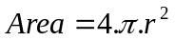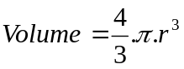

CONCLUSION:

HOMEWORK: Write a program to find out the roots of a second degree equation: ax²+bx+c=0
Necessary formulas for this;
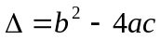 and 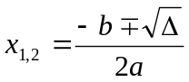

Teacher Director

